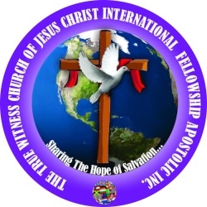**True Witness Church of Jesus Christ (Apostolic)**

**377 Hamilton Ave., Paterson, NJ**

**Phone**: 973-569-3417; **Email**: [t_witness@yahoo.com](mailto:t_witness@yahoo.com)

Baby Dedication Request Form

**CHILD’S INFORMATION**

Full Name: :

Date of Birth: Gender:

Hospital:

**PARENTS’ INFORMATION**

|  |  |  |
| --- | --- | --- |
|  | **Mother** | **Father** |
| **Name** |  |  |
| **Address** |  |  |
| **Phone Number** |  |  |
| **Email Address** |  |  |

**Record the name(s) of all godparent(s):**

|  |  |
| --- | --- |
| 1. | 2. |
| 3. | 4. |

[If you have more than 4 godparents, please write additional names on the back of the form.]

**When would you like the dedication to be done?**

1st Preference: _________________ 2nd Preference: __________________ 3rd Preference: ________________

**FOR OFFICIAL USE ONLY**

Amount Paid: __________________ Dedication Date: __________________

Pastor’s Signature: ________________________________________ Date: _____________

Notes: